Copper Construction
410 McIntosh Street
Vidalia, GA. 30474
912-537-6420
912-537-3214
info@copperga.com

Application - Page 1
Date______________________________________________Name ________________________________________________

Phone _____________________________________________

Alternate Phone _________________________________

Email _____________________________________________

Address

Street Name & Number______________________________________________
City_____________________________State____________________Zip Code______________________________

I am interested in: Full Time____________ Part Time_________________ Sub Contracting__________________________

Pay Desired __________________Put hourly wage or yearly wage desired

Date you can start work_________________________________________

What local area do you prefer to work?____________________________

Position Desired Are you authorized to work in the US? Yes_________________ No___________________

Federal law requires that employers hire only individuals who are authorized to be lawfully employed in the United States. In compliance with these laws, Copper Construction, Inc. will verify the status of every individual offered employment with the company.

Are you under 18 years of age? Yes______________________ No____________________________

If so, do you have a work permit? Yes_________________________No________________________

Are you capable of performing the essential functions of the job which you are applying with or without reasonable accommodation? Yes__________________No____________________

Are you a veteran or active duty military? Yes___________________No________________________

Copper Construction, Inc. is an equal opportunity employer and does not discriminate against any applicant or employee because of race, religion, sex, national origin, disability, or military, or veteran, status in accordance with federal law. In addition, Copper Construction makes reasonable accommodation to people with disabilities in accordance with applicable laws

Application Section 2 Please list your job and military experience (most recent first)
Company Name________________________________

Position Or Title__________________________________

Dates Worked There _____________________________ (Put date started and date left)

Company Address

Street Address__________________________________

City_________________________________State_____________________________Zip Code_________________________

Supervisors Name _______________________________________

Supervisors Phone Number ______________________________

Type of Business ______________________________________

Starting Pay _____________________________Ending Pay_____________________________

Reason For leaving _________________________________________________________________

Describe Your Major Responsibilities And Duties ______________________________________________________________________________

Application Section 2
Company Name _________________________________________

Position Or Title ___________________________________________

Dates Worked There ________________________________________ ( Put date started and date left.)

Company Address

Street Address______________________________________________________________________________________________

City________________________________________State_____________________________ZipCode________________________

Supervisors Name _____________________________________________
Supervisors Phone Number ___________________________________

Type of Business ________________________________________________

Starting Pay __________________________Ending Pay ______________________

Reason For leaving______________________________________________________

Describe Your Major Responsibilities And Duties ________________________________________________________________

Application Section 2
Company Name_______________________________________________

Position Or Title_______________________________________________

Dates Worked There_______________________________________( Put date started and date left.)

Company Address

Street Address___________________________________________________________________________________
City____________________________________________State_________________________________________________Zip Code____

Supervisors Name______________________________________________________________________

Supervisors Phone Number ___________________________________________________________

Type of Business____________________________________________________________________

Starting Pay________________________________ Ending Pay____________________________

Reason For leaving ________________________________________________________________
Describe Your Major Responsibilities And Duties _______________________________________________________________________________________

Education
Name of High School ___________________________
Address
Street ______________________________
City________________________ State __________________ Zip Code_________________Phone
Years Completed ______________ Year Graduated_________________

Name of College_____________________________________

Address

Street__________________________________-
City____________________________________State_________________________________Zipcode_________________ Phone_________________________________
Professional License________________________________________State Issuing License_______________________________

Professional License________________________________________State Issuing License_______________________________

License Number______________________________________________License Number______________________________________

Any Additional Licenses, State Issuing & Number___________________________________________________________________

List Three Personal References With Phone Numbers
1.___________________________________________________________________________________________________

2.___________________________________________________________________________________________________

3.__________________________________________________________________________________________________
All information contained is true and I have read the agreement below.
Signature___________________________________________________________________

Read the following and agree by signing the application.
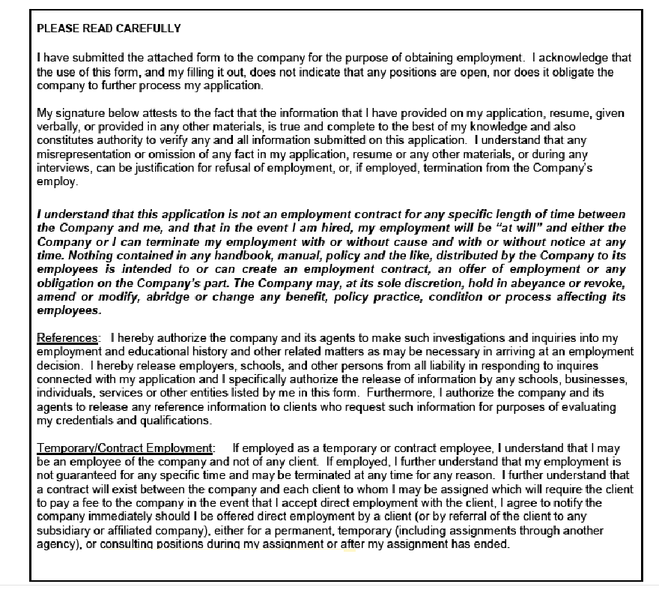

About

Copper Construction Company Inc.
410 McIntosh Street Vidalia, GA. 30474
912-537-6420
912-537-3214
info@copperga.com

